EXPERIMENT 6: LINK JIRA TASKS WITH CONFLUENCE
AIM:
To link Jira tasks with a Confluence page for tracking project progress in a Library Management System.
PROCEDURE:
- Open Confluence and create a page titled Library Management System Project Overview.
- Insert at least five Jira issues using the Jira macro.
- Display the issue details and statuses such as To Do, In Progress, and Done.
- Add a progress bar to show the percentage of completed tasks.
- Publish the page and take a screenshot.
OUTPUT:
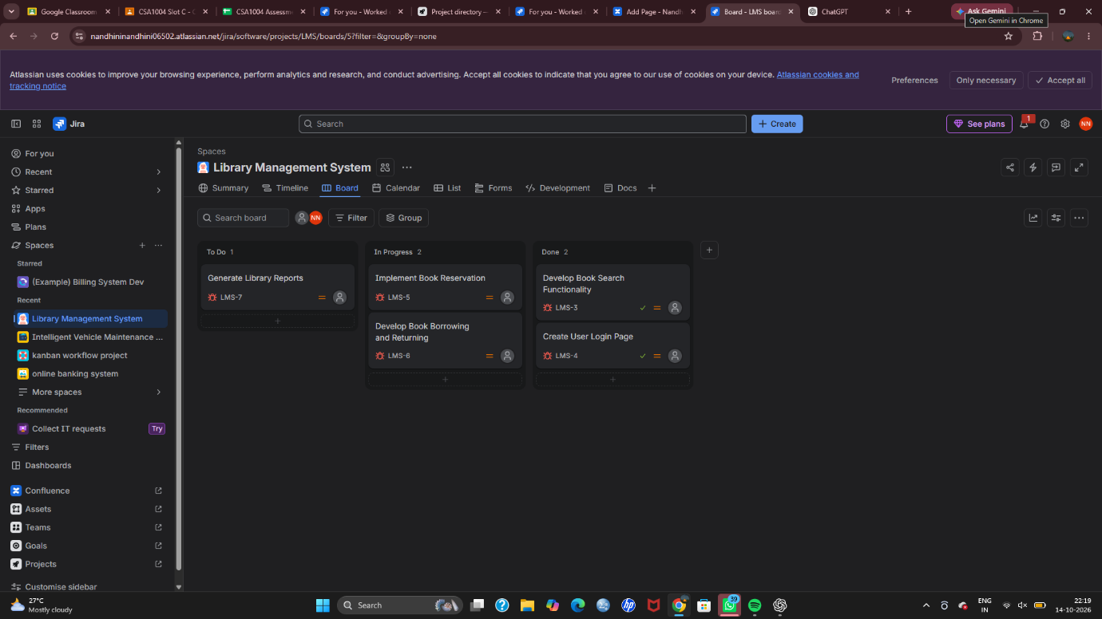

RESULT:
Successfully linked Jira tasks with Confluence and displayed task statuses and project progress.

